**Table of Contents**

Level 1 1

Level 2 3

Level 3 3

Level 4 6

Level 5 14

Level 6 19

Day 1 19

Day 2 22

Day 3 22

Day 4 22

Day 5 22

Level 7 22

Level 8 22

Level 9 22

Level 10 22

Level 11 22

Level 12 22

# Level 1

**Slide 3 Exercise 1**

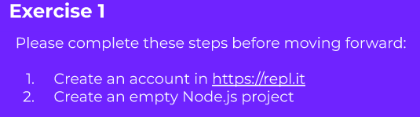

**Slide 6 Ex 2**

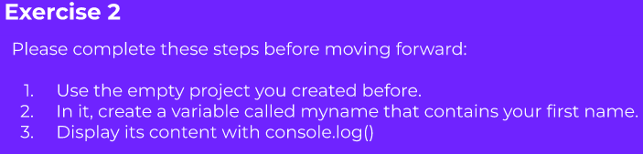

**Answer**

const myName = 'Kehali';

console.log(myName);

Slide

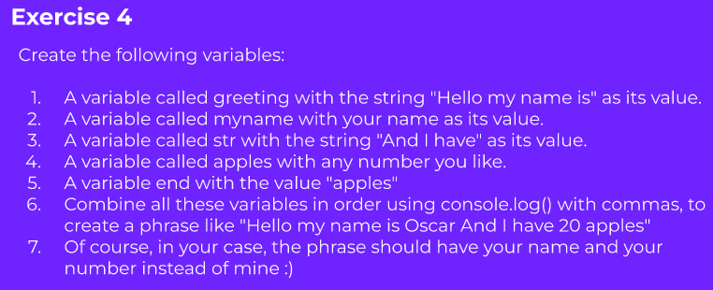

Answer

const greeting = 'Hello my name is';

const myName = 'Kehali';

const str = 'And I have';

const apples = 5;

const last = "apples";

console.log(greeting, myName, str, apples, last);

|Slide 11 EX 6

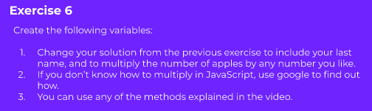

Answer

const greeting = 'Hello my name is';

const myName = 'Kehali';

const myName2 = 'Tsehay';

const str = 'And I have';

var apples = 5;

const last = "apples";

apples *= 3;

console.log(greeting, myName, myName2, str, apples, last);

Slide 13 EX Final Assessement

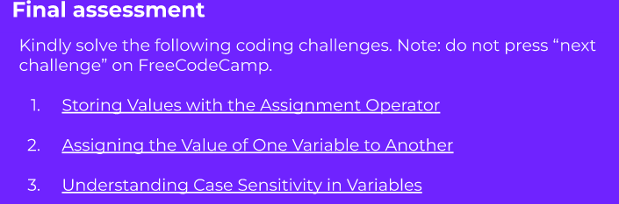

Answer 1

// Setup

var a;

// Only change code below this line

a = 7;

Answer 2

var a;

a = 7;

var b;

// Only change code below this line

b = a;

Answer 3

let a = “javascript”

let b= “Javascript”

// Does a equals with b?

// The answer is no. Because javascript language is case sensitive i.e j is not equals with J.

# Level 2

# Level 3

Slide 16 Exercise 8

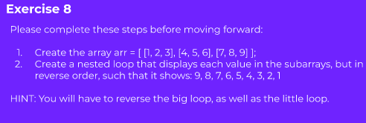

Answer

let arr = [[1,2,3], [4,5,6], [7,8,9]];

for (let i = arr.length - 1; i >= 0; i--){

for (let j = arr[i].length - 1; j >= 0; j--){

console.log(arr[i][j]);

}

}

Slide 18 Exercise 9

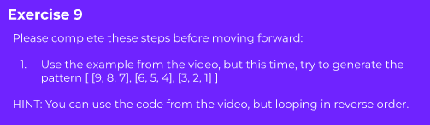

Answer

let bigarr = [];

let count = 9;

for (let i = 0; i < 3; i++){

let subarr = [];

for (let j = 0; j < 3; j++){

subarr.push(count);

count--;

}

bigarr.push(subarr);

}

console.log(bigarr);

Slide 20 Exercise 10

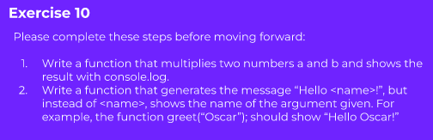

Answer

function multi(a, b){

return a * b;

}

console.log(multi(3,5));

function greeting(name){

return "Hello, " + name;

}

console.log(greeting("kehali"));

Slide 22 Exercise 11

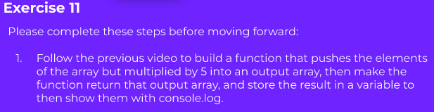

Answer

let arr = [];

function multi(Array){

for (let i = 0; i < Array.length; i++){

arr.push(Array[i] * 5);

}

return arr;

}

let output = multi([2, 3, 4, 5]);

console.log(output);

Slide 24 Exercise 12

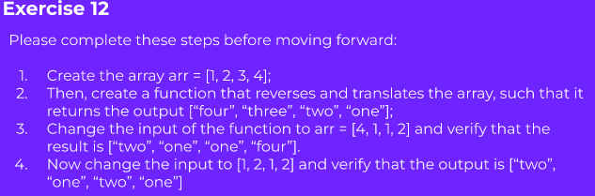

Answer

let arr = [1, 2, 3, 4];

let output = [];

function reverseAndTrans(arr){

for (let i = arr.length -1; i >= 0; i--){

//output.push(arr[i]);

if (arr[i] === 4){

output.push("Four");

}

if (arr[i] === 3){

output.push("Three");

}

if (arr[i] === 2){

output.push("Two");

}

if (arr[i] === 1){

output.push("One");

}

}

return output;

}

let result = reverseAndTrans(arr);

console.log(result);

Level 4

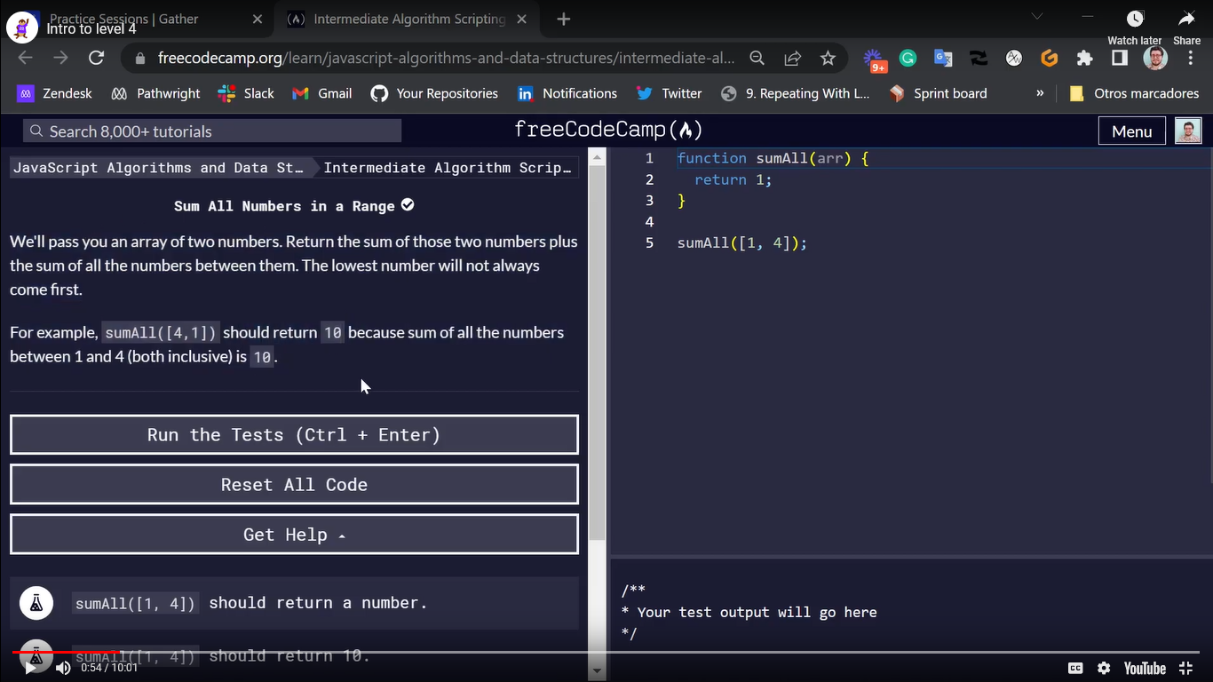

Answer

function sum(arr){

let first = arr[0];

let last = arr[1];

if (first > last){

first = arr[1];

last = arr[0];

}

let output = 0;

for (let i = first; i <= last; i++){

output += i;

}

return output;

}

let result = sum([4, 1]);

console.log(result);

# Level 4

Slide 4 Ex 1

Change Celecious to faherniet

Answer

function convertCtoF(celsius) {

  let fahrenheit;

   fahrenheit = celsius * 9/5 + 32;

  return fahrenheit;

}

convertCtoF(30);

Slide 8

Reversing string

function reverseString(str) {

  let result = '';

  let count = str.length -1;

  for (let i = 0; i < str.length; i++){

    result += str[count];

    count--

  }

  return result;

}

reverseString("hello");

Slide 12 EX 3

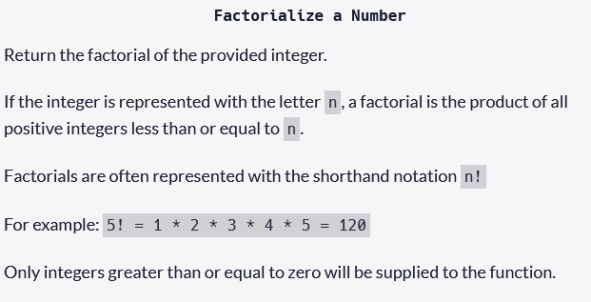

Answer

function factorialize(num) {

  let fact = 1;

  for (let i = 1; i <= num; i++){

    fact *= i;

  }

  return fact;

}

let result = factorialize(10);

console.log(result);

Slide 16 Ex 4

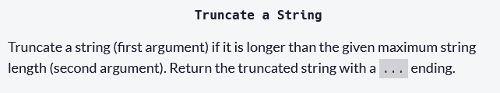

Answer

function truncateString(str, num) {

    let output = str.substring(0, num);

    if (str.length > num){

      output = output+"..."

    }

  return output;

}

let result = truncateString("Absolutely Longer", 2);

console.log(result);

Slide 20 Ex 5

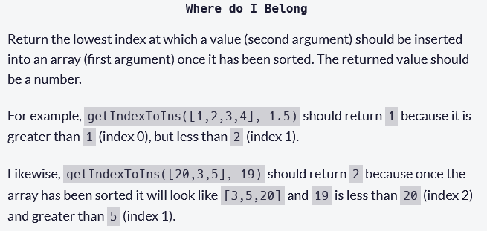

Answer

function getIndexToIns(arr, num) {

  let belong = 0;

  for (let i = 0; i < arr.length; i++){

    if (arr[i] < num){

      belong++;

    }

  }

  //console.log(belong)

  return belong;

}

let result = getIndexToIns([10, 4, 8, 3, 5, 9], 7);

console.log(result);

Slide 23 Ex 6

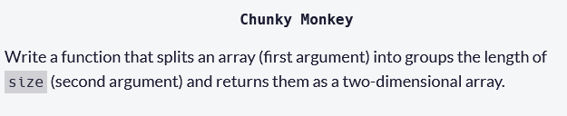

Answer

function chunkArrayInGroups(arr, size) {

  let output = [];

  let subarr = [];

  let subctr = 0;

  for (let i = 0; i < arr.length; i++){

    if (subctr == size){

      subctr = 0;

      output.push(subarr);

      subarr = [];

    }

    subarr.push(arr[i]);

    //console.log(subctr, subarr);

    subctr++;

  }

    output.push(subarr);

  return output;

}

Slide 27 Ex 7

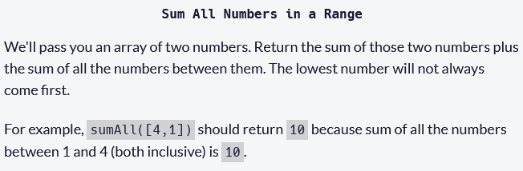

Answer

function sumAll(arr) {

  let first = arr[0];

  let last = arr[1]

  let sum = 0;

  if (first > last){

    first = arr[1];

    last = arr[0]

  }

  for (let i = first; i <= last; i++){

    //console.log(i);

    sum += i

  }

  return sum;

}

let result = sumAll([4, 1]);

console.log(result);

Slide 32 Ex 8

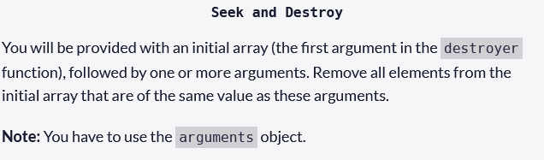

Answer

function destroyer(arr) {

  let input = arguments[0];

  let output = [];

  let destroy = [];

  for (let i = 1; i < arguments.length; i++){

    destroy.push(arguments[i]);

      }

    for (let i = 0; i < input.length; i++){

      if (destroy.includes(input[i]) === false){

        output.push(input[i]);

      }

    }

  console.log(output)

  return output;

}

destroyer([1, 2, 3, 1, 2, 3], 2, 3,);

Slide 35 Ex 9

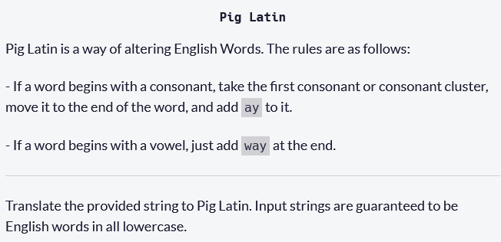

Answer

function translatePigLatin(str) {

  let firstLetter = str[0];

  let vowels = "aeiou";

  if (vowels.includes(firstLetter) === true){

    return str+"way";

  }

  let cluster ="";

  let i = 0;

  while((vowels.includes(str[i]) === false) && i < str.length){

    cluster += str[i];

    i++;

  }

  return str.substring(i) + cluster + "ay";

}

let result = translatePigLatin("consonant");

console.log(result);

Slide 39 Ex 10

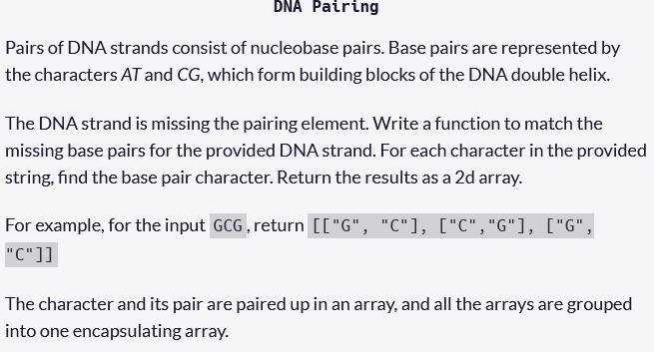

Answer

function pairElement(str) {

  let output = [];

  for (let i = 0; i < str.length; i++){

    if(str[i] === "A"){

      output.push(["A", "T"])

    }

    if(str[i] === "T"){

      output.push(["T", "A"])

    }

    if(str[i] === "G"){

      output.push(["G", "C"])

    }

    if(str[i] === "C"){

      output.push(["C", "G"])

    }

  }

  return output;

}

let result = pairElement("CTCTA");

console.log(result);

# Level 5

**Exercise 11**

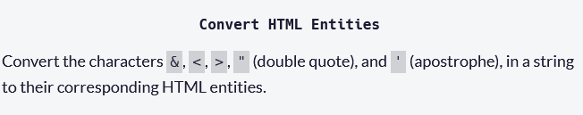

**Answer**

function convertChar(letters){

  if (letters === "&"){

    return "&amp;"

  } else if (letters === "<"){

    return "&lt;"

  } else if (letters === ">"){

    return "&gt;"

  } else if (letters === "'"){

    return "&apos;"

  } else if (letters === '"'){

    return "&quot;"

  }

}

function convertHTML(str) {

  let special = ['&', '<', '>', "'", '"']

for (let i = 0; i < str.length; i++){

  if (special.indexOf(str[i]) != -1){

    str = str.slice(0, i) + convertChar(str[i]) + str.slice(i+1);

  }

}

  return str;

}

convertHTML("Dolce & Gabbana");

**Exercise 12**

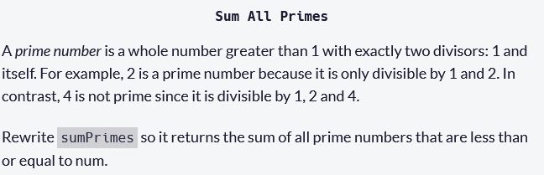

**Answer**

function isPrime(number){

  let count = 2;

    while (count < number){

      if (number % count === 0){

        return false;

      }

      count++;

    }

    return true;

}

function sumPrimes(num) {

  let count = 2;

  let sum = 0;

  while (count <= num){

    if (isPrime(count)){

      sum += count;

    }

    count += 1;

  }

  return sum;

}

console.log(sumPrimes(10))

**Exercise 13**

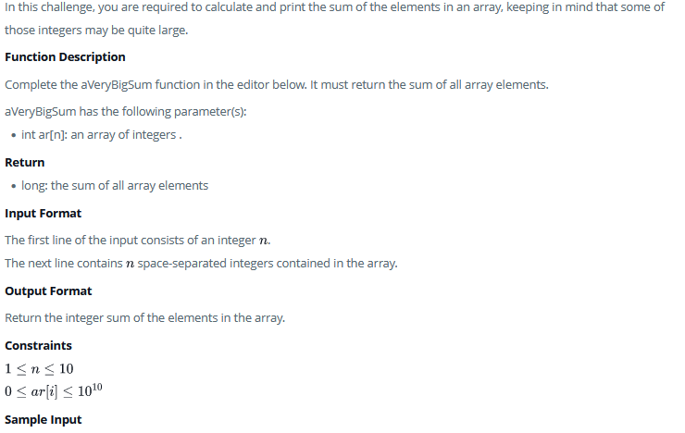

**Answer**

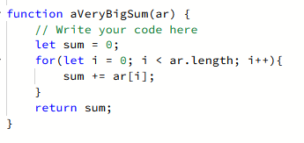

**Exercise 14**

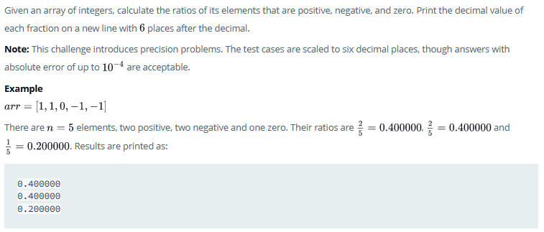

**Answer**

function plusMinus(arr) {

    // Write your code here

    let countposi = 0;

    let countnega = 0;

    let countzero = 0;

    for (let i = 0; i < arr.length; i++){

        if (arr[i] > 0){

            countposi++;

        } else if (arr[i] < 0){

            countnega++;

        } else if (arr[i] == 0){

            countzero++;

        }

    }

    console.log((countposi/arr.length).toFixed(6));

    console.log((countnega/arr.length).toFixed(6));

    console.log((countzero/arr.length).toFixed(6));

}

**Exercise 15**

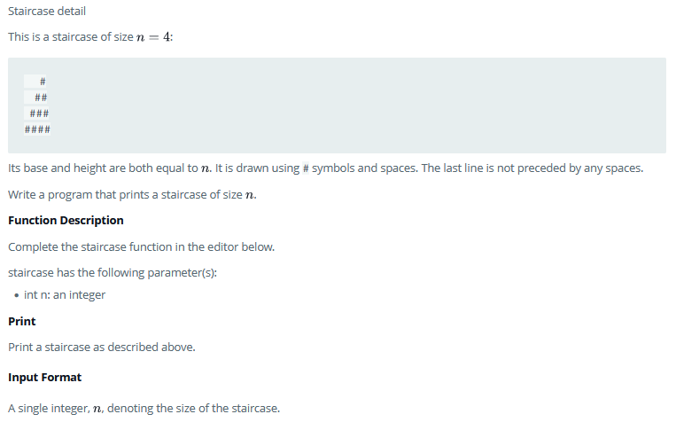

**Answer**

function staircase(n) {

for (let i = 1; i <= n; i++) {

let step = '';

for (let j = 1; j <= n; j++) {

if (j <= n-i) {

step += ' '

} else {

step += '#';

}

}

console.log(step);

}

}

**Output 1**

     #

    ##

   ###

  ####

 #####

######

**Option 2**

function stairCase(n){

  let output = '';

  for (let i = 1; i <= n; i++){

    for(let j = 1; j <= n-1; j++){

      output += "";

    }

    for (let k = 1; k <= i; k++){

      output += "#";

    }

    output += "\n";

  }

  return output;

}

console.log(stairCase(6));

**Output**

#

##

###

####

#####

######

**Option 3**

function stairCase(n){

  let output = '';

  for (let i = 1; i <= n; i++){

    for(let j = 1; j <= n; j++){

      output += " ";

    }

    for (let k = n; k >= i; k--){

      output += "#";

    }

    output += "\n";

  }

  return output;

}

console.log(stairCase(6));

**Output**

      ######

      #####

      ####

      ###

      ##

      #

**Exercise 16**

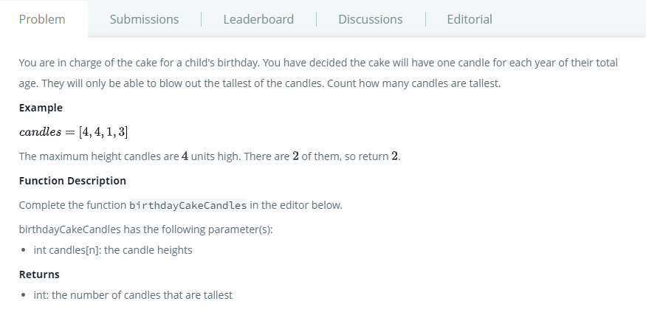

**Answer**

function birthdayCakeCandles(candles) {

// Write your code here

let tallest = candles[0];

for (let i = 1; i < candles.length; i++){

if (candles[i] > tallest){

tallest = candles[i];

}

}

console.log(tallest);

let ctr = 0;

for (let i = 0; i < candles.length; i++){

if (candles[i] === tallest){

ctr++;

}

}

return ctr;

}

console.log(birthdayCakeCandles([3, 4, 4, 1, 3, 9]));

**Exercise 17**

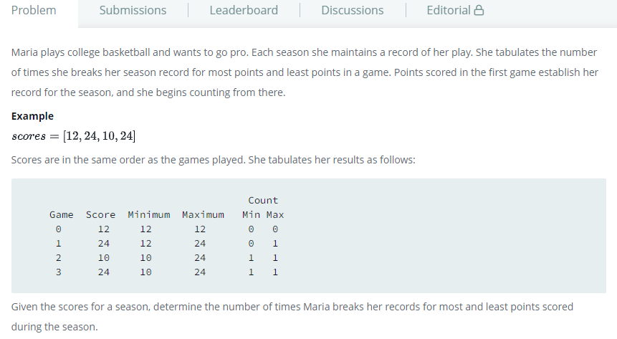

**Answer**

function breakingRecords(scores) {

let highctr = 0;

let lowctr = 0;

let high = scores[0];

let low = scores[0];

for (let i = 1; i < scores.length; i++){

//console.log("the highest score is ", high)

if (scores[i] > high){

high = scores[i];

highctr++;

// console.log("now hihgest is updated to", high);

// console.log(highctr);

}

//console.log("the lowest score is ", low)

if (scores[i] < low){

low = scores[i];

lowctr++;

// console.log("now lowest is updated to", low);

// console.log(lowctr);

}

}

return [highctr, lowctr];

}

console.log(breakingRecords([3, 4, 21, 36, 10, 28, 35, 5, 24, 42]));

**Exercise 18;**

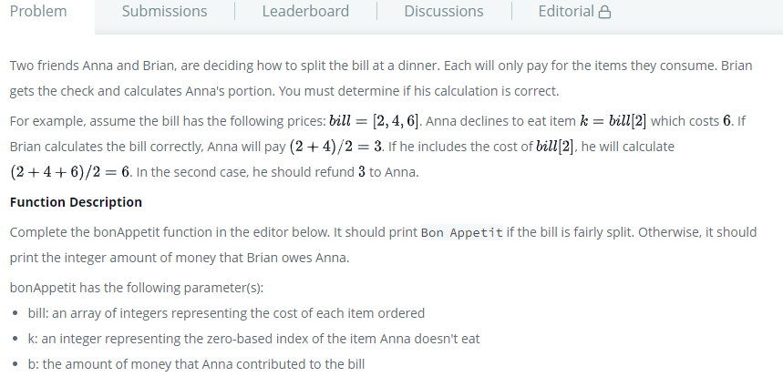

**Answer**

function bonAppetit(bill, k, b) {

// Write your code here

let brainChareged = b;

let itemAnnaDonnoteat = bill[k];

let sharedBill = [];

for (let i = 0; i < bill.length; i++){

if ((bill[i] != itemAnnaDonnoteat)){

sharedBill.push(bill[i]);

}

}

console.log(sharedBill);

let brainactualBill = 0;

let totalBill = 0;

for (let i = 0; i < sharedBill.length; i++){

totalBill += sharedBill[i]

}

brainactualBill = totalBill/2;

let result = brainChareged - brainactualBill;

if (result === 0){

console.log("Bon Appetit");

}

console.log(totalBill);

console.log(brainChareged);

console.log(brainactualBill);

console.log(result);

return result;

}

**Exercise 19**

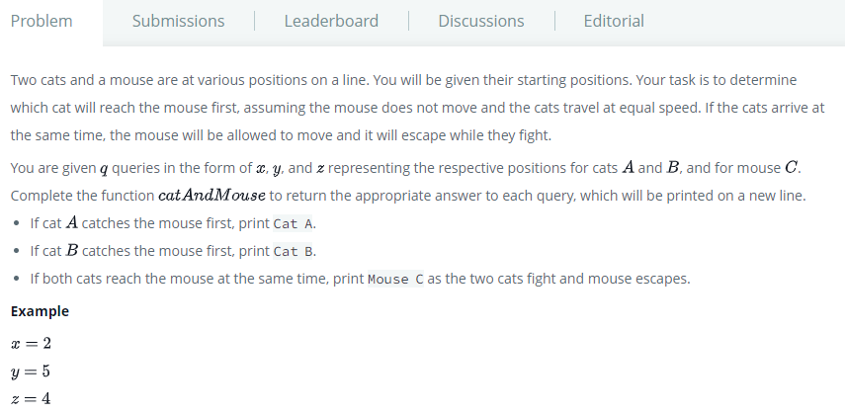

**Answer**

function catAndMouse(x, y, z) {

let catA = x;

let catB = y;

let mouseC = z;

if (Math.abs(catA - mouseC) < Math.abs(catB - mouseC)){

return "Cat A";

} else if (Math.abs(catA - mouseC) > Math.abs(catB - mouseC)){

return "Cat B";

} else if (Math.abs(catA - mouseC) == Math.abs(catB - mouseC)) {

return "Mouse C";

}

}

console.log(catAndMouse(1,3,2));

**Exercise 20**

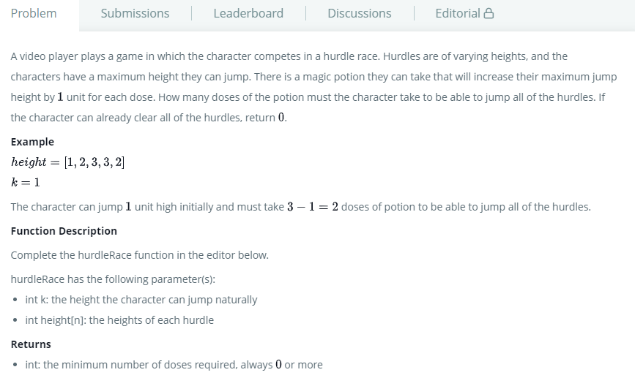

**Answer**

function hurdleRace(k, height) {

// Write your code here

function compare(a,b){

return a-b;

}

let newarr = height.sort(compare);

let largest = newarr[0];

for (let i = 1; i < newarr.length; i++){

if (newarr[i] > newarr[i-1]);

largest = newarr[i];

}

for (let i = 0; i < newarr.length; i++){

if (k >= largest){

return 0;

}

}

console.log(newarr);

let result = largest - k;

return result;

}

# Level 6

## Day 1

**Problem #1 If-then-else**:

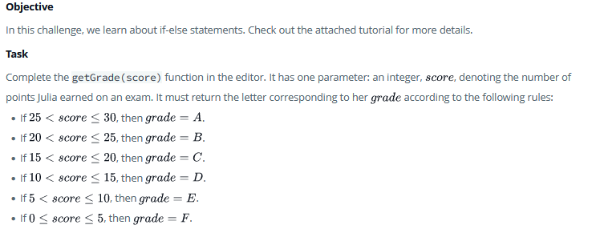

Answer

function getGrade(score) {

    let grade;

    if (score > 25 && score <= 30 ){

        grade = "A";

    }

    if (score > 20 && score <= 25 ){

       grade = "B";

    }

    if (score > 15 && score <= 20 ){

        grade = "C";

    }

    if (score > 10 && score <= 15 ){

        grade = "D";

    }

    if (score > 5 && score <= 10 ){

        grade = "E";

    }

    if (score >= 0 && score <= 5 ){

        grade = "F";

    }

    return grade;

}

getGrade(11);

**Problem #2 Simple array sum**:

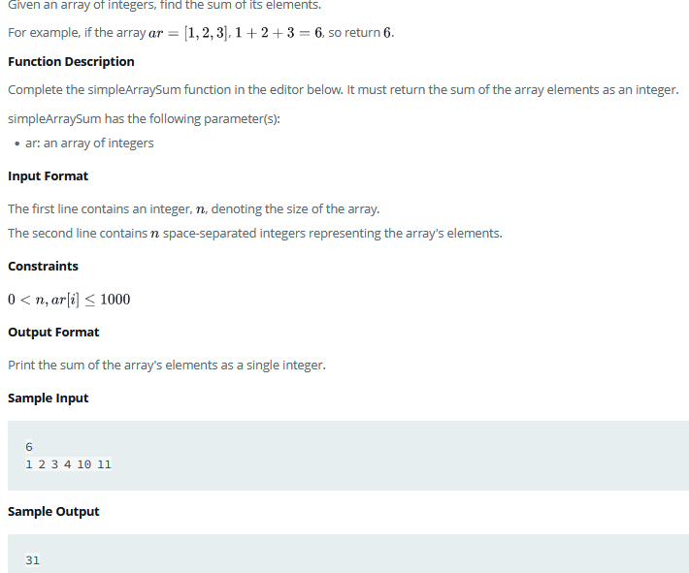

Answer

function simpleArraySum(ar) {

    // Write your code here

    let sum =0;

    for (let i = 0; i < ar.length; i++){

        sum += ar[i]

    }

  return sum;

}

simpleArraySum([1, 2, 3, 4, 10, 11])

**Problem #3 Arrays**:

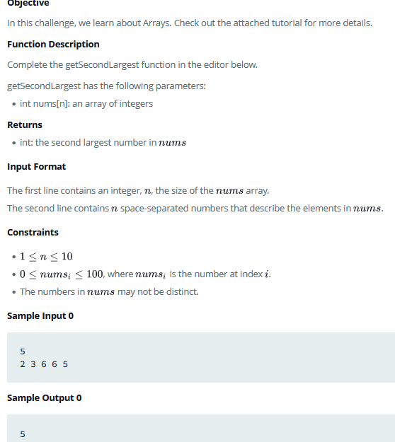

Answer

function getSecondLargest(nums) {

    // Complete the function

    let largest = nums[0];

    for (let i = 0; i < nums.length; i++){

        if (nums[i] > largest){

            largest = nums[i];

        }

    }

    let secondLargest = nums[0];

    for (let i = 0; i < nums.length; i++){

        if (nums[i] > secondLargest && nums[i] < largest){

            secondLargest = nums[i];

        }

    }

  return secondLargest;

}

getSecondLargest([1, 2, 3, 4, 10, 11]);

**Problem #4 Loops**:

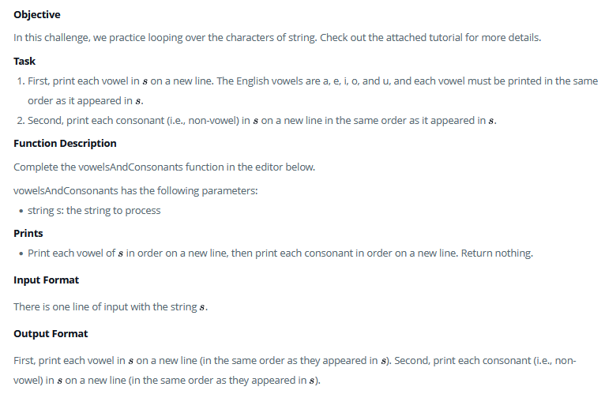

Answer

function vowelsAndConsonants(s) {

  let vowels = 'aeiou'

  let consonants = 'bcdfghjklmnpqrstvwxyz';

  let output = ''

  for (let char of s){

    if (vowels.includes(char)){

      output += char;

      output += "\n"

    }

  }

  for (let char of s){

    if (consonants.includes(char)){

      output += char;

      output += "\n"

    }

  }

  return output;

}

**Or**

function vowelsAndConsonants(s) {

let vowels = 'aeiou'

let consonants = 'bcdfghjklmnpqrstvwxyz';

let output = ''

for (let char of s){

if (vowels.includes(char)){

output += char;

output += "\n"

}

}

for (let char of s){

if (consonants.includes(char)){

output += char;

output += "\n"

}

}

return output;

}

console.log(vowelsAndConsonants("javascriptloops"));

**Problem #5 Multiples and modulus**:

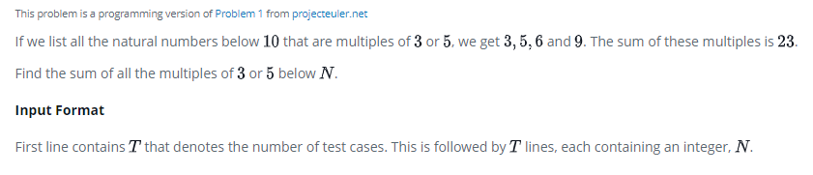

Answer

function multiplesOf(num) {

if (num < 3){

return "You have entered a number less than three";

}

let sum = 0;

for (var i = 3; i < num; i++) {

if (i % 3 === 0 || i % 5 === 0) {

sum += i;

}

}

return sum;

}

console.log(multiplesOf(2));

## Day 2

**Problem #1 Birthday-cake-candles**:

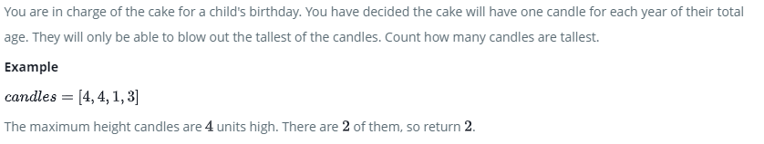

Answer

function birthdayCakeCandles(candles) {

// Write your code here

let count = 0;

let highest = candles[0];

for (let i = 0; i < candles.length; i++){

if (candles[i] > highest){

highest = candles[i];

}

}

for (let i = 0; i < candles.length; i++){

if (candles[i] == highest){

count++;

}

}

return count;

}

console.log(birthdayCakeCandles([4]));

**Problem #2 Sharelock-and-array**

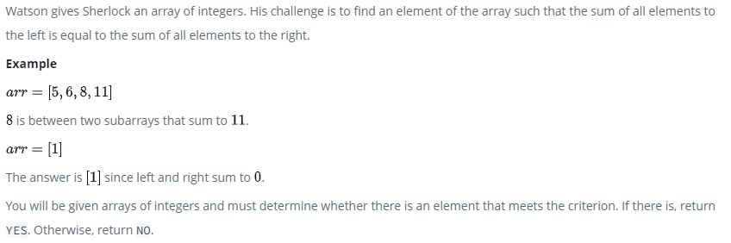

Answer

function balancedSums(arr) {

    // Write your code here

    let sum = arr.reduce((acc,val) => acc + val);

    let leftSum = 0;

    for (let i = 0; i < arr.length; i++){

        sum -= arr[i];

        if (sum === leftSum){

            return "YES";

        }

        leftSum += arr[i];

    }

    return "NO"

}

**Problem #3 Count-objects**:

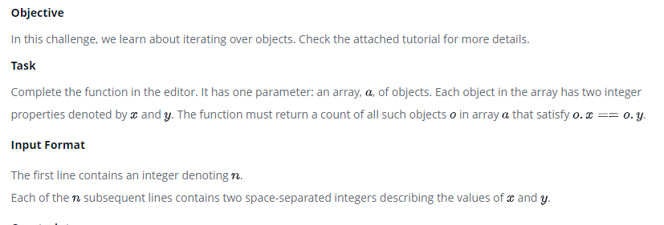

Answer

function getCount(objects) {

    let count = 0;

    for (let i = 0; i < objects.length; i++){

        if (objects[i].x === objects[i].y){

            count++

        }

    }

    return count;

}

**Problem #4 Missing Number**:

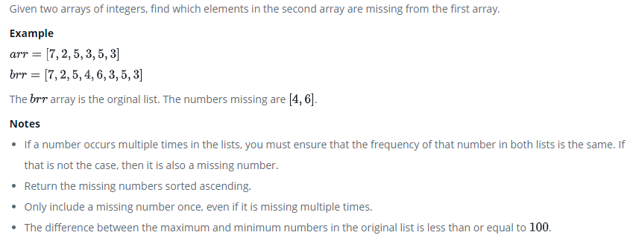

Answer

function missingNumbers(arr, brr) {

// Write your code here

let hash = {};

for (let i = 0; i < brr.length; i++){

let key = brr[i];

hash[key] = 0;

}

for (let i = 0; i < brr.length; i++){

let key = brr[i];

hash[key] += 1;

}

for (let i = 0; i < arr.length; i++){

let key = arr[i];

hash[key] -= 1;

}

let output = [];

for(const e in hash){

if (hash[e] > 0){

output.push(e);

}

}

return output;

}

## Day 3: Debugging

**Problem 1. Celicus to Faherniet (No problem found)**

function convertToF(celsius) {

let fahrenheit= celsius * 9 / 5 + 32;

return fahrenheit;

}

console.log(convertToF(30));

**Problem 2 Reverse string (No problem found)**

function reverseString(str) {

let output = '';

for (let i = str.length - 1; i >= 0; i --) {

output += str[i];

}

return output;

};

console.log(reverseString("Hello!!"));

**Problem 3: Factorialize a number (No problem found)**

function factorial(n){

let a = [];

let counter = 0;

for(let i = n; i > 1; i --){

a[counter] = i;

counter ++;

//fills the array with backwards numbers

}

let product = 1;

//multiplies each value of a and stores it in the new product array

for (let j = 0; j < a.length; j++) {

product = a[j] * product;

}

return product;

}

**Problem 4: Turnicatibg a string (No problem found)**

function truncateString(str, num) {

if (num < str.length ) {

return str.slice(0, num) + "...";

} else {

return str;

}

};

console.log(truncateString("A-tisket a-tasket A green and yellow basket", 8));

**Problem 5: Where do I belong (Change I to I in the for loop)**

function getIndexToIns(arr, num) {

arr.sort(function(a,b) {

return a - b;

});

for (let i = 0; i < arr.length; i++) {

if (arr[i] >= num) {

return i;

}

}

return arr.length;

};

**Problem 6: Chunky monkey (No problem exist)**

function chunkArrayInGroups(arr, size) {

let result=[];

for (let i = 0; i < arr.length; i += size){

result.push(arr.slice(i, i + size));

}

return result;

};

console.log(chunkArrayInGroups(["a", "b", "c", "d"], 2));

**Sum of All Odd Length Subarrays (No done yet)**

**Problem 7: Apple and Orange (on the third for loop correct >= ;s&& to >= s &&)**

function countApplesAndOranges(s, t, a, b, apples, oranges) {

// Write your code here

let positionA = [];

let positionO = [];

let counterA = 0;

let counterO = 0;

for (let i = 0; i < apples.length; i ++) {

positionA[i] = apples[i] + a;

}

for (let i = 0; i < oranges.length; i ++) {

positionO[i] = oranges[i] + b;

}

for (let i = 0; i < positionA.length; i ++) {

if(positionA[i] >= s && positionA[i]<=t){

counterA ++

}

}

for(let i = 0; i < positionO.length; i ++) {

if(positionO[i] >= s && positionO[i] <= t) {

counterO++

}

}

console.log(counterA);

console.log(counterO);

}

console.log(countApplesAndOranges(7, 11, 5, 15, [-2, 2, 1], [5, -6]));

**Count odd number in the interval range (Not solved yet)**

var countOdds = function(low, high) {

let output = []

for (let i = low; i <= high; i++){

if (!(i % 2 == 0)){

output.push(i);

}

}

return output;

};

console.log(countOdds(3,7));

**Problem 8: Sum of all in the range (No problem found)**

function sumAll(arr) {

arr = arr.sort((a, b) => a - b);

let sum=0;

for(let i = arr[0]; i <= arr[1]; i ++) {

sum=i+sum

}

return sum;

};

console.log(sumAll([4, 1]));

**Problem 9: Seek and destroy (No problem Found)**

function destroyer(arr) {

let valsToRemove = Object.values(arguments).slice(1);

for (let i = 0; i < arr.length; i++) {

for (let j = 0; j < valsToRemove.length; j ++) {

if (arr[i] === valsToRemove[j]) {

delete arr[i];

}

}

}

return arr.filter(item => item !== null);

};

console.log(destroyer([1, 2, 5,7,3, 1, 2, 3], 2, 3));

**Problem 10: Pig Latin ( on str.replace line change “a” to “ay”)**

function translatePigLatin(str) {

let consonantRegex = /^[^aeiou]+/;

let myConsonants = str.match(consonantRegex);

return myConsonants !== null ? str.replace(consonantRegex,"").concat(myConsonants).concat("ay") : str.concat("way");

};

console.log(translatePigLatin ("schwonsonant"));

**Problem 11: Plus-Minus (No problem found)**

function plusMinus(arr) {

// Write your code here

let outputP = 0;

let outputN = 0;

let outputZ = 0;

for(let i = 0; i < arr.length; i ++) {

if(arr[i]>0) {

outputP ++;

} else if (arr[i] < 0) {

outputN++

} else if (arr[i] === 0) {

outputZ++

}

};

const resultP = outputP / arr.length;

const resultN = outputN / arr.length;

const resultZ= outputZ / arr.length;

console.log(resultP.toFixed(6));

console.log(resultN.toFixed(6));

console.log(resultZ.toFixed(6));

}

console.log(plusMinus([2,3,-8,-9,0,0]));

**Problem 12: Staircase (No problem found)**

function staircase(n) {

for (let i = 1; i <= n; i ++) {

console.log(" ".repeat(n - i) + "#".repeat(i));

}

}

console.log(staircase(6));

**Problem 13: Birthday cake (No problem found)**

function birthdayCakeCandles(candles) {

let max = candles[0];

let counter=0;

for (let i = 0; i < candles.length; i ++) {

if (candles[i] > max) {

max = candles[i];

}

}

for (let i = 0; i < candles.length; i ++) {

if (candles[i] === max) {

counter++;

}

}

return counter;

}

console.log(birthdayCakeCandles([3,1,4,4,5,2]));

**Problem 14: Breaking Records (Add return [max, min];)**

function breakingRecords(scores) {

let high = scores[0];

let low = scores[0];

let [ max, min ] = [ 0, 0 ];

for (let i = 1; i < scores.length; i ++) {

if (scores[i] > high) {

high = scores[i]; max++;

}

if (scores[i] < low) {

low = scores[i]; min++;

}

}

return [max, min];

};

**Problem 15: Bon Appetit(No problem found)**

function bonAppetit(bill, k, b) {

bill.splice(k,1);

let sum = 0;

for(let i = 0; i < bill.length; i ++) {

sum = bill[i] + sum;

}

let division = sum / 2;

if(division === b){

console.log("Bon Appetit")

} else {

console.log( b - division);

}

};

console.log(bonAppetit([3,10,2,9],1,7));

**Problem 16: Cat and Mouse (No problem found)**

function catAndMouse(x, y, z) {

let diffx = Math.abs(z-x);

let diffy = Math.abs(z-y);

if(diffx === diffy) {

return 'Mouse C';

} else {

if(diffx < diffy) {

return 'Cat A';

} else {

return 'Cat B';

}

}

};

console.log(catAndMouse(1, 2, 3));

**Problem 17: HurdleRace (remove the end closing curly bracket);**

function hurdleRace(k, height) {

let x = height.sort((a, b) => a - b).pop();

if((x - k) > 0){

return x - k;

} else {

return 0;

}

};

console.log(hurdleRace(1, [1,2,3,3,2]))

## Day 4

## Day 5

# Level 7

# Level 8

Problem 1

Say Hello to HTML Elements

Answer

<h1>Hello World</h1>

Problem 2

Add an h2 tag that says "CatPhotoApp" to create a second HTML element below your "Hello World" h1 element.

Answer

<h1>Hello World</h1>

<h2>CatPhotoApp</h2>

Problem 3

Create a p element below your h2 element, and give it the text Hello Paragraph.

Answer

<h1>Hello World</h1>

<h2>CatPhotoApp</h2>

<p>Hello Paragraph</p>

Problem 4

Within the existing main element, insert an img element before the existing p elements.

Now set the src attribute so that it points to the url https://cdn.freecodecamp.org/curriculum/cat-photo-app/relaxing-cat.jpg

Finally, don't forget to give your img element an alt attribute with applicable text.

Answer

<h2>CatPhotoApp</h2>

<main>

<img src = "https://cdn.freecodecamp.org/curriculum/cat-photo-app/relaxing-cat.jpg" alt = "Cat photo"

  <p>Kitty ipsum dolor sit amet, shed everywhere shed everywhere stretching attack your ankles chase the red dot, hairball run catnip eat the grass sniff.</p>

  <p>Purr jump eat the grass rip the couch scratched sunbathe, shed everywhere rip the couch sleep in the sink fluffy fur catnip scratched.</p>

</main>

Problem 5

Link to External Pages with Anchor Elements

<h2>CatPhotoApp</h2>

<main>

<a href="https://www.freecatphotoapp.com">cat photos</a>

  <img src="https://cdn.freecodecamp.org/curriculum/cat-photo-app/relaxing-cat.jpg" alt="A cute orange cat lying on its back.">

  <p>Kitty ipsum dolor sit amet, shed everywhere shed everywhere stretching attack your ankles chase the red dot, hairball run catnip eat the grass sniff.</p>

  <p>Purr jump eat the grass rip the couch scratched sunbathe, shed everywhere rip the couch sleep in the sink fluffy fur catnip scratched.</p>

</main>

Problem 6

Nest an Anchor Element within a Paragraph

Answer

h2>CatPhotoApp</h2>

<main>

<p>

    View more <a href="https://www.freecatphotoapp.com" target="_blank">cat photos</a>

  </p>

  <img src="https://cdn.freecodecamp.org/curriculum/cat-photo-app/relaxing-cat.jpg" alt="A cute orange cat lying on its back.">

  <p>Kitty ipsum dolor sit amet, shed everywhere shed everywhere stretching attack your ankles chase the red dot, hairball run catnip eat the grass sniff.</p>

  <p>Purr jump eat the grass rip the couch scratched sunbathe, shed everywhere rip the couch sleep in the sink fluffy fur catnip scratched.</p>

</main>

Problem 7

Make Dead Links Using the Hash Symbol

Answer

<h2>CatPhotoApp</h2>

<main>

  <p>Click here to view more <a href="#" target="_blank">cat photos</a>.</p>

  <img src="https://cdn.freecodecamp.org/curriculum/cat-photo-app/relaxing-cat.jpg" alt="A cute orange cat lying on its back.">

  <p>Kitty ipsum dolor sit amet, shed everywhere shed everywhere stretching attack your ankles chase the red dot, hairball run catnip eat the grass sniff.</p>

  <p>Purr jump eat the grass rip the couch scratched sunbathe, shed everywhere rip the couch sleep in the sink fluffy fur catnip scratched.</p>

</main>

Problem 8

Turn an Image into a Link

Answer

<main>

  <p>Click here to view more <a href="#"><img src="https://cdn.freecodecamp.org/curriculum/cat-photo-app/relaxing-cat.jpg" alt="A cute orange cat lying on its back."></a>.</p>

  <p>Kitty ipsum dolor sit amet, shed everywhere shed everywhere stretching attack your ankles chase the red dot, hairball run catnip eat the grass sniff.</p>

  <p>Purr jump eat the grass rip the couch scratched sunbathe, shed everywhere rip the couch sleep in the sink fluffy fur catnip scratched.</p>

</main>

Problem 9

Create a Bulleted Unordered List

Answer

<h2>CatPhotoApp</h2>

<main>

  <p>Click here to view more <a href="#">cat photos</a>.</p>

  <a href="#"><img src="https://cdn.freecodecamp.org/curriculum/cat-photo-app/relaxing-cat.jpg" alt="A cute orange cat lying on its back."></a>

  <p>Cat loves the following</p>

  <ul>

    <li>Meat</li>

    <li>Milk</li>

    <li>Rat</li>

  </ul>

Problem 10

Create an Ordered List

Answer

<h2>CatPhotoApp</h2>

<main>

  <p>Click here to view more <a href="#">cat photos</a>.</p>

  <a href="#"><img src="https://cdn.freecodecamp.org/curriculum/cat-photo-app/relaxing-cat.jpg" alt="A cute orange cat lying on its back."></a>

  <p>Top 3 things cats hate:</p>

  <ol>

    <li>Dog</li>

    <li>Lion</li>

    <li>Nothing</li>

  </ol>

</main>

Problem 11

# Create a Text Field

Answer

<h2>CatPhotoApp</h2>

<main>

  <p>Click here to view more <a href="#">cat photos</a>.</p>

  <a href="#"><img src="https://cdn.freecodecamp.org/curriculum/cat-photo-app/relaxing-cat.jpg" alt="A cute orange cat lying on its back."></a>

  <p>Things cats love:</p>

  <ul>

    <li>cat nip</li>

    <li>laser pointers</li>

    <li>lasagna</li>

  </ul>

  <p>Top 3 things cats hate:</p>

  <ol>

    <li>flea treatment</li>

    <li>thunder</li>

    <li>other cats</li>

  </ol>

<input type="text" placeholder="Enter your cats name">

</main>

Problem 12

Create form Element

Answer

<h2>CatPhotoApp</h2>

<main>

  <p>Click here to view more <a href="#">cat photos</a>.</p>

  <a href="#"><img src="https://cdn.freecodecamp.org/curriculum/cat-photo-app/relaxing-cat.jpg" alt="A cute orange cat lying on its back."></a>

  <p>Things cats love:</p>

  <ul>

    <li>cat nip</li>

    <li>laser pointers</li>

    <li>lasagna</li>

  </ul>

  <p>Top 3 things cats hate:</p>

  <ol>

    <li>flea treatment</li>

    <li>thunder</li>

    <li>other cats</li>

  </ol>

  <form action="https://www.freecatphotoapp.com/submit-cat-photo">

  <input type="text" placeholder="cat photo URL">

  </form>

</main>

Problem 13

Create a button

Answer

<h2>CatPhotoApp</h2>

<main>

  <p>Click here to view more <a href="#">cat photos</a>.</p>

  <a href="#"><img src="https://cdn.freecodecamp.org/curriculum/cat-photo-app/relaxing-cat.jpg" alt="A cute orange cat lying on its back."></a>

  <p>Things cats love:</p>

  <ul>

    <li>cat nip</li>

    <li>laser pointers</li>

    <li>lasagna</li>

  </ul>

  <p>Top 3 things cats hate:</p>

  <ol>

    <li>flea treatment</li>

    <li>thunder</li>

    <li>other cats</li>

  </ol>

  <form action="https://www.freecatphotoapp.com/submit-cat-photo">

    <input type="text" placeholder="cat photo URL">

    <button type="submit">Submit</button>

  </form>

</main>

Problem 14

Nest Many Elements within a Single div Element;

Answer

<h2>CatPhotoApp</h2>

<main>

  <p>Click here to view more <a href="#">cat photos</a>.</p>

  <a href="#"><img src="https://cdn.freecodecamp.org/curriculum/cat-photo-app/relaxing-cat.jpg" alt="A cute orange cat lying on its back."></a>

<div>

  <p>Things cats love:</p>

  <ul>

    <li>cat nip</li>

    <li>laser pointers</li>

    <li>lasagna</li>

  </ul>

  <p>Top 3 things cats hate:</p>

  <ol>

    <li>flea treatment</li>

    <li>thunder</li>

    <li>other cats</li>

  </ol>

</div>

  <form action="https://www.freecatphotoapp.com/submit-cat-photo">

    <label for="indoor"><input id="indoor" type="radio" name="indoor-outdoor" value="indoor" checked> Indoor</label>

    <label for="outdoor"><input id="outdoor" type="radio" name="indoor-outdoor" value="outdoor"> Outdoor</label><br>

    <label for="loving"><input id="loving" type="checkbox" name="personality" value="loving" checked> Loving</label>

    <label for="lazy"><input id="lazy" type="checkbox" name="personality" value="lazy"> Lazy</label>

    <label for="energetic"><input id="energetic" type="checkbox" name="personality" value="energetic"> Energetic</label><br>

    <input type="text" placeholder="cat photo URL" required>

    <button type="submit">Submit</button>

  </form>

</main>

Problem 15

Define the Head and Body of an HTML Document

Answer

<!DOCTYPE html>

<html>

<head>

<title>The best page ever</title>

</head>

<body>

<h1>The best page ever</h1>

<p>Cat ipsum dolor sit amet, jump launch to pounce upon little yarn mouse, bare fangs at toy run hide in litter box until treats are fed. Go into a room to decide you didn't want to be in there anyway. I like big cats and i can not lie kitty ipsum dolor sit amet, shed everywhere shed everywhere stretching attack your ankles chase the red dot, hairball run catnip eat the grass sniff. Meow i could pee on this if i had the energy for slap owner's face at 5am until human fills food dish yet scamper. Knock dish off table head butt cant eat out of my own dish scratch the furniture. Make meme, make cute face. Sleep in the bathroom sink chase laser but pee in the shoe. Paw at your fat belly licks your face and eat grass, throw it back up kitty ipsum dolor sit amet, shed everywhere shed everywhere stretching attack your ankles chase the red dot, hairball run catnip eat the grass sniff.</p>

</body>

</html>

# Level 9

Problem 1

Change the color property

Answer

<h2 style="color: red;">CatPhotoApp</h2>

<main>

  <p>Click here to view more <a href="#">cat photos</a>.</p>

  <a href="#"><img src="https://cdn.freecodecamp.org/curriculum/cat-photo-app/relaxing-cat.jpg" alt="A cute orange cat lying on its back."></a>

  <div>

    <p>Things cats love:</p>

    <ul>

      <li>cat nip</li>

      <li>laser pointers</li>

      <li>lasagna</li>

    </ul>

    <p>Top 3 things cats hate:</p>

    <ol>

      <li>flea treatment</li>

      <li>thunder</li>

      <li>other cats</li>

    </ol>

  </div>

  <form action="https://freecatphotoapp.com/submit-cat-photo">

    <label><input type="radio" name="indoor-outdoor" checked> Indoor</label>

    <label><input type="radio" name="indoor-outdoor"> Outdoor</label><br>

    <label><input type="checkbox" name="personality" checked> Loving</label>

    <label><input type="checkbox" name="personality"> Lazy</label>

    <label><input type="checkbox" name="personality"> Energetic</label><br>

    <input type="text" placeholder="cat photo URL" required>

    <button type="submit">Submit</button>

  </form>

</main>

Problem 2

Use CSS Selectors to Style Elements

Answer

<style>

  h2 {

    color: blue;

  }

</style>

<h2>CatPhotoApp</h2>

<main>

  <p>Click here to view more <a href="#">cat photos</a>.</p>

  <a href="#"><img src="https://cdn.freecodecamp.org/curriculum/cat-photo-app/relaxing-cat.jpg" alt="A cute orange cat lying on its back."></a>

  <div>

    <p>Things cats love:</p>

    <ul>

      <li>cat nip</li>

      <li>laser pointers</li>

      <li>lasagna</li>

    </ul>

    <p>Top 3 things cats hate:</p>

    <ol>

      <li>flea treatment</li>

      <li>thunder</li>

      <li>other cats</li>

    </ol>

  </div>

  <form action="https://freecatphotoapp.com/submit-cat-photo">

    <label><input type="radio" name="indoor-outdoor" checked> Indoor</label>

    <label><input type="radio" name="indoor-outdoor"> Outdoor</label><br>

    <label><input type="checkbox" name="personality" checked> Loving</label>

    <label><input type="checkbox" name="personality"> Lazy</label>

    <label><input type="checkbox" name="personality"> Energetic</label><br>

    <input type="text" placeholder="cat photo URL" required>

    <button type="submit">Submit</button>

  </form>

</main>

Problem 3

Use a CSS Class to Style an Element

Answer

<style>

  .red-text {

    color: red;

  }

</style>

<h2 class="red-text">CatPhotoApp</h2>

<main>

  <p>Click here to view more <a href="#">cat photos</a>.</p>

  <a href="#"><img src="https://cdn.freecodecamp.org/curriculum/cat-photo-app/relaxing-cat.jpg" alt="A cute orange cat lying on its back."></a>

  <div>

    <p>Things cats love:</p>

    <ul>

      <li>cat nip</li>

      <li>laser pointers</li>

      <li>lasagna</li>

    </ul>

    <p>Top 3 things cats hate:</p>

    <ol>

      <li>flea treatment</li>

      <li>thunder</li>

      <li>other cats</li>

    </ol>

  </div>

  <form action="https://freecatphotoapp.com/submit-cat-photo">

    <label><input type="radio" name="indoor-outdoor" checked> Indoor</label>

    <label><input type="radio" name="indoor-outdoor"> Outdoor</label><br>

    <label><input type="checkbox" name="personality" checked> Loving</label>

    <label><input type="checkbox" name="personality"> Lazy</label>

    <label><input type="checkbox" name="personality"> Energetic</label><br>

    <input type="text" placeholder="cat photo URL" required>

    <button type="submit">Submit</button>

  </form>

</main>

Problem 4

Style Multiple Elements with a CSS Class

Answer

<style>

  .red-text {

    color: red;

  }

</style>

<h2 class="red-text">CatPhotoApp</h2>

<main>

  <p class="red-text">Click here to view more <a href="#">cat photos</a>.</p>

Problem 5

Change the Font Size of an Element

Answer

<style>

  .red-text {

    color: red;

  }

  p {

    font-size: 16px;

  }

</style>

<h2 class="red-text">CatPhotoApp</h2>

<main>

  <p class="red-text">Click here to view more <a href="#">cat photos</a>.</p>

Problem 6

Set the Font Family of an Element

Answer

<style>

  .red-text {

    color: red;

  }

  p {

    font-size: 16px;

    font-family: monospace;

  }

</style>

<h2 class="red-text">CatPhotoApp</h2>

<main>

  <p class="red-text">Click here to view more <a href="#">cat photos</a>.</p>

Problem 7

Import a Google Font

Answer

<link href="https://fonts.googleapis.com/css?family=Lobster" rel="stylesheet" type="text/css">

<style>

  .red-text {

    color: red;

  }

  h2 {

    font-family: Lobster;

  }

  p {

    font-size: 16px;

    font-family: monospace;

  }

</style>

<h2 class="red-text">CatPhotoApp</h2>

<main>

  <p class="red-text">Click here to view more <a href="#">cat photos</a>.</p>

Problem 8;

Specify How Fonts Should Degrade

Answer

<!--<link href="https://fonts.googleapis.com/css?family=Lobster" rel="stylesheet" type="text/css"> -->

<style>

  .red-text {

    color: red;

  }

  h2 {

    font-family: Lobster, monospace;

  }

  p {

    font-size: 16px;

    font-family: monospace;

  }

</style>

<h2 class="red-text">CatPhotoApp</h2>

<main>

  <p class="red-text">Click here to view more <a href="#">cat photos</a>.</p>

Problem 9

Size your image

Answer

<link href="https://fonts.googleapis.com/css?family=Lobster" rel="stylesheet" type="text/css">

<style>

  .red-text {

    color: red;

  }

  h2 {

    font-family: Lobster, monospace;

  }

  p {

    font-size: 16px;

    font-family: monospace;

  }

  .smaller-image {

    width: 100px;

  }

</style>

<h2 class="red-text">CatPhotoApp</h2>

<main>

  <p class="red-text">Click here to view more <a href="#">cat photos</a>.</p>

  <a href="#"><img class="smaller-image" src="https://cdn.freecodecamp.org/curriculum/cat-photo-app/relaxing-cat.jpg" alt="A cute orange cat lying on its back."></a>

Problem 10

Adding border to your element

Answer

<link href="https://fonts.googleapis.com/css?family=Lobster" rel="stylesheet" type="text/css">

<style>

  .red-text {

    color: red;

  }

  h2 {

    font-family: Lobster, monospace;

  }

  p {

    font-size: 16px;

    font-family: monospace;

  }

  .smaller-image {

    width: 100px;

  }

  .thick-green-border {

    border: 10px solid green;

  }

</style>

<h2 class="red-text">CatPhotoApp</h2>

<main>

  <p class="red-text">Click here to view more <a href="#">cat photos</a>.</p>

  <a href="#"><img class="smaller-image thick-green-border" src="https://cdn.freecodecamp.org/curriculum/cat-photo-app/relaxing-cat.jpg" alt="A cute orange cat lying on its back."></a>

  <div class="thick-green-border">

    <p>Things cats love:</p>

    <ul>

      <li>cat nip</li>

      <li>laser pointers</li>

      <li>lasagna</li>

    </ul>

    <p>Top 3 things cats hate:</p>

    <ol>

      <li>flea treatment</li>

      <li>thunder</li>

      <li>other cats</li>

    </ol>

  </div>

# Level 10

Problem 1

Give a Background Color to a div Element

Answer

<link href="https://fonts.googleapis.com/css?family=Lobster" rel="stylesheet" type="text/css">

<style>

  .red-text {

    color: red;

  }

  h2 {

    font-family: Lobster, monospace;

  }

  p {

    font-size: 16px;

    font-family: monospace;

  }

  .thick-green-border {

    border-color: green;

    border-width: 10px;

    border-style: solid;

    border-radius: 50%;

  }

  .smaller-image {

    width: 100px;

  }

  .silver-background {

    background-color: silver;

  }

</style>

<h2 class="red-text">CatPhotoApp</h2>

<main>

  <p class="red-text">Click here to view more <a href="#">cat photos</a>.</p>

  <a href="#"><img class="smaller-image thick-green-border" src="https://cdn.freecodecamp.org/curriculum/cat-photo-app/relaxing-cat.jpg" alt="A cute orange cat lying on its back."></a>

  <div class="silver-background">

    <p>Things cats love:</p>

    <ul>

      <li>cat nip</li>

      <li>laser pointers</li>

      <li>lasagna</li>

    </ul>

    <p>Top 3 things cats hate:</p>

    <ol>

      <li>flea treatment</li>

      <li>thunder</li>

      <li>other cats</li>

    </ol>

  </div>

Problem 2

Create Texture by Adding a Subtle Pattern as a Background Image

Answer

<style>

  body {

    background: url("https://cdn-media-1.freecodecamp.org/imgr/MJAkxbh.png")

  }

</style>

Problem 3

Set id for an element

Answer

<link href="https://fonts.googleapis.com/css?family=Lobster" rel="stylesheet" type="text/css">

<style>

  .red-text {

    color: red;

  }

  h2 {

    font-family: Lobster, monospace;

  }

  p {

    font-size: 16px;

    font-family: monospace;

  }

  .thick-green-border {

    border-color: green;

    border-width: 10px;

    border-style: solid;

    border-radius: 50%;

  }

  .smaller-image {

    width: 100px;

  }

  .silver-background {

    background-color: silver;

  }

</style>

<h2 class="red-text">CatPhotoApp</h2>

<main>

  <p class="red-text">Click here to view more <a href="#">cat photos</a>.</p>

  <a href="#"><img class="smaller-image thick-green-border" src="https://cdn.freecodecamp.org/curriculum/cat-photo-app/relaxing-cat.jpg" alt="A cute orange cat lying on its back."></a>

  <div class="silver-background">

    <p>Things cats love:</p>

    <ul>

      <li>cat nip</li>

      <li>laser pointers</li>

      <li>lasagna</li>

    </ul>

    <p>Top 3 things cats hate:</p>

    <ol>

      <li>flea treatment</li>

      <li>thunder</li>

      <li>other cats</li>

    </ol>

  </div>

  <form id="cat-photo-form" action="https://freecatphotoapp.com/submit-cat-photo">

    <label><input type="radio" name="indoor-outdoor" checked> Indoor</label>

    <label><input type="radio" name="indoor-outdoor"> Outdoor</label><br>

    <label><input type="checkbox" name="personality" checked> Loving</label>

    <label><input type="checkbox" name="personality"> Lazy</label>

    <label><input type="checkbox" name="personality"> Energetic</label><br>

    <input type="text" placeholder="cat photo URL" required>

    <button type="submit">Submit</button>

  </form>

</main>

Problem 4

Use Id attribute to style the element

Answer

<link href="https://fonts.googleapis.com/css?family=Lobster" rel="stylesheet" type="text/css">

<style>

  .red-text {

    color: red;

  }

  h2 {

    font-family: Lobster, monospace;

  }

  p {

    font-size: 16px;

    font-family: monospace;

  }

  .thick-green-border {

    border-color: green;

    border-width: 10px;

    border-style: solid;

    border-radius: 50%;

  }

  .smaller-image {

    width: 100px;

  }

  .silver-background {

    background-color: silver;

  }

  #cat-photo-form {

    background: green;

  }

</style>

<h2 class="red-text">CatPhotoApp</h2>

<main>

  <p class="red-text">Click here to view more <a href="#">cat photos</a>.</p>

  <a href="#"><img class="smaller-image thick-green-border" src="https://cdn.freecodecamp.org/curriculum/cat-photo-app/relaxing-cat.jpg" alt="A cute orange cat lying on its back."></a>

  <div class="silver-background">

    <p>Things cats love:</p>

    <ul>

      <li>cat nip</li>

      <li>laser pointers</li>

      <li>lasagna</li>

    </ul>

    <p>Top 3 things cats hate:</p>

    <ol>

      <li>flea treatment</li>

      <li>thunder</li>

      <li>other cats</li>

    </ol>

  </div>

  <form action="https://freecatphotoapp.com/submit-cat-photo" id="cat-photo-form">

    <label><input type="radio" name="indoor-outdoor" checked> Indoor</label>

    <label><input type="radio" name="indoor-outdoor"> Outdoor</label><br>

    <label><input type="checkbox" name="personality" checked> Loving</label>

    <label><input type="checkbox" name="personality"> Lazy</label>

    <label><input type="checkbox" name="personality"> Energetic</label><br>

    <input type="text" placeholder="cat photo URL" required>

    <button type="submit">Submit</button>

  </form>

</main>

Problem 5

Adjust the Padding of an Element

Answer

<style>

  .injected-text {

    margin-bottom: -25px;

    text-align: center;

  }

  .box {

    border-style: solid;

    border-color: black;

    border-width: 5px;

    text-align: center;

  }

  .yellow-box {

    background-color: yellow;

    padding: 10px;

  }

  .red-box {

    background-color: crimson;

    color: #fff;

    padding: 20px;

  }

  .blue-box {

    background-color: crimson;

    color: #fff;

    padding: 20px;

  }

</style>

<h5 class="injected-text">margin</h5>

<div class="box yellow-box">

  <h5 class="box red-box">padding</h5>

  <h5 class="box blue-box">padding</h5>

</div>

Problem 6

# Level 11

# Level 12